‘The Scriptures’ name for God when Daniel and Ezra original in Aramaic language

http://evidenceforchristianity.org/why-are-sections-of-daniel-and-ezra-in-aramaic/

QUESTION:
A few sections of Ezra (4:8-6:18;7:12-26) and Daniel (2:4b-7:28) are written in Aramaic. From some of the research that I have read I’ve come to the conclusion that it’s most likely “Official Aramaic”, however I can’t seem to find a good reason why the author would write in Aramaic and Hebrew. I was wondering do you have any thoughts on why the author would write both in Aramiac and Hebrew? Thanks!
Answer:
I answer this in my book on Daniel. Do you have a copy? If not, you should get one! www.ipibooks.com. The reason for inclusion of Aramaic in the books of Ezra and Daniel is clearly different. The reason Ezra has Aramaic text is that the original letters contained in it were in Aramaic. In order to have the Aramaic parts of be in Hebrew would have required that the letters be translated into Hebrew. Because the majority of Jews at that time spoke Aramaic, it would have been superfluos to translate the Aramaic letters. The reason that part of Daniel is in Aramaic is less clear. This requires some speculation. In my book, I speculate that the entire book was in Aramaic and that, for some reason, when an editor collected the final book of Daniel, he decided to include some material in Aramaic and some in Hebrew. I do not know why this was done. This is a bit of a mystery. In my book on Daniel, I speculate the the original of Daniel was written in Aramaic, not Hebrew. My guess (and it is a bit of a guess) is that the book was translated into Hebrew and, for some reason, the editor who produced the text of Daniel which ended up in the Jewish Bible used a combination of the original Aramaic and of the translated Hebrew. It is possible to argue for the reverse, that the Aramaic section was translated from Hebrew, but because Daniel probably spoke Aramaic as his primary language, I argue that the original was in Aramaic. Again, bear in mind that this is speculation.
John Oakes

The name of God in Aramaic:

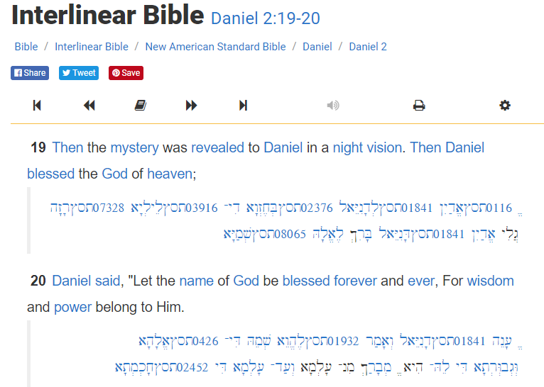

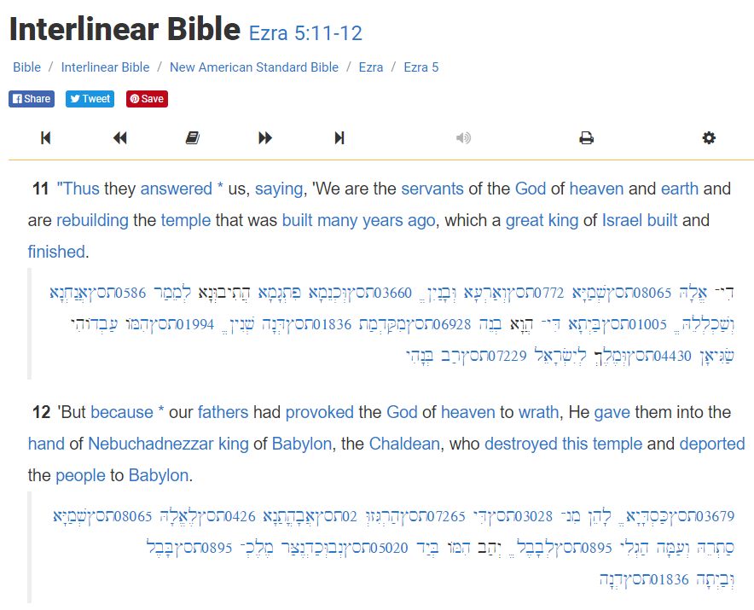

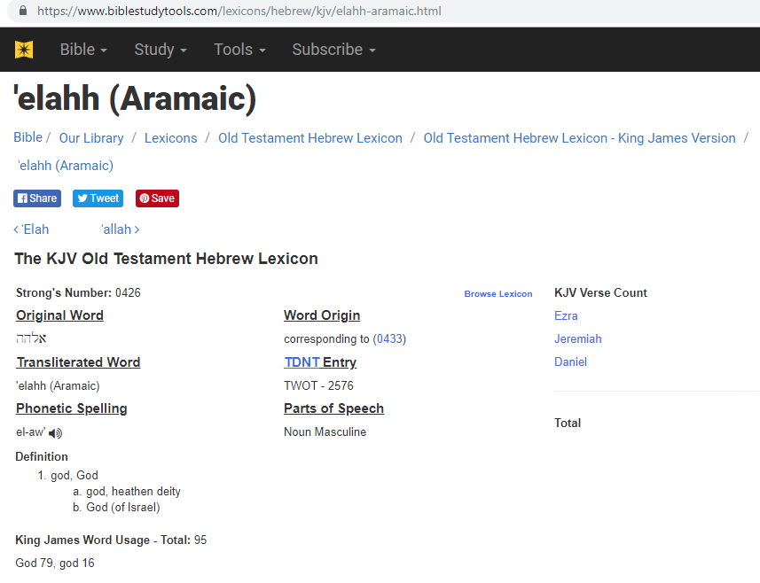

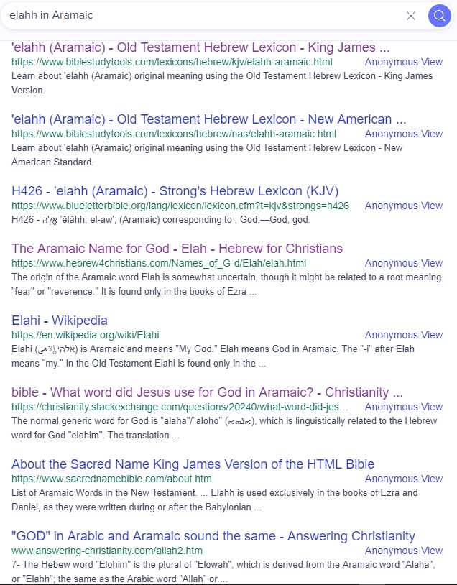

https://www.hebrew4christians.com/Names_of_G-d/Elah/elah.html

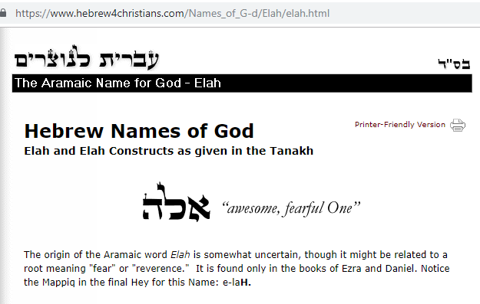

https://christianity.stackexchange.com/questions/20240/what-word-did-jesus-use-for-god-in-aramaic

The name of God in the Hebrew Bible is YHWH, pronounced Yahweh or Jehovah.
There are many words used in the Hebrew Bible for the word 'God' (not the name of God), such us El(god), Elohim (god, plural form), El Shaddai (god almighty), Adonai (master), Elyon (highest) and Avinu (our father) are regarded by many religious Jews not as names, but as epithets highlighting different aspects of YHWH and the various 'roles' of God (source).
From Wikipedia article on Allah,
The term Allāh is derived from a contraction of the Arabic definite article al- "the" and ilāh "deity, god" to al-lāh meaning "the [sole] deity, God" (ὁ θεὸς μόνος, ho theos monos). Cognates of the name "Allāh" exist in other Semitic languages, including Hebrew and Aramaic. Biblical Hebrew mostly uses the plural form (but functional singular) Elohim. The corresponding Aramaic form is ʼĔlāhā ܐܠܗܐ in Biblical Aramaic and ʼAlâhâ ܐܲܠܵܗܵܐ in Syriac as used by the Assyrian Church, both meaning simply 'God'.
Elohim is not the name of God, it is simply 'God' in Hebrew. Many languages have some similarities because many of them share the same origin. 'God' in English, 'Elohim' in Hebrew, 'Elaha' in Aramaic, 'Alaha' in Syriac etc. but the name of God in the Bible is YHWH, not Allah as some Muslim scholars may try to relate them. Hence, the God in the Bible is YHWH and the god in the Qu'ran is Allah. The most specific Hebrew name for God is YHWH, also mistakenly referred to as Yehovah, meaning self-existent and eternal. YHWH is rooted from ‘Hayah’, the to be verb, which is from ‘Hava’, to breathe, or to be, which connects to ‘Ayil’. Finally ‘Ayil’ leads us back to ‘El’, which is the root of all the Semitic names for God. YHWH is spoken aloud on rare Jewish celebrations as just “Ya.” Jews often replaced the actual name of God for Adonay (Lord) orally and in their written scripts.
For instance, see this typical translation of Exodus 20:7
Thou shalt not take the name of YHWH thy Elohim in vain; for YHWH will not hold him guiltless that taketh his name in vain.
Jesus spoke Aramaic many times during His ministry, hence, he must have used the word 'Eli' or 'Elaha' (ʼĔlāhā) many times to say 'God'. For instance, while Jesus was on the cross, He cried out in Aramaic.

About three in the afternoon Jesus cried out in a loud voice, “Eli, Eli[a], lema sabachthani?” (which means “My God, my God, why have you forsaken me?”) [Matthew 27:46, NIV]
[a] Some manuscripts Eloi, Eloi

Can you please give me some sources for proving "Eli, Eli[a], lema sabachthani" is Aramaic. (I have to submit some reasonable proven source for helping one of my friends who engaged on a Muslim - Christian debate). – manuthalasseril Oct 26 '13 at 8:49
- 1
@manuthalasseril Scholars agree that it is Aramaic. See this Wikipedia article. Even if it is Hebrew, it still doesn't mean that Jesus was calling for Allah the Muslim god. Islam came 600 years after Jesus. – Mawia Oct 26 '13 at 9:16
- It would be interesting to note how one goes from pronouncing the tetragrammaton direct YHWH as Jehovah. Not sure if it is off the subject, but if my name is Bubbles in english, my name is still bubbles in aramaic. I wouldn't recognize it otherwise. – Bubbles Jun 4 '14 at 0:27
- 4
To address what I think is the underlying point here: I think most linguists say that the Hebrew words "El" and "Elohim" share common origins with the Arabic word "Allah". But that hardly proves that Jews worshipped the God of Islam. Both "Elohim" and "Allah" are general words meaning "God". Consider: There have been plenty of times in history that two men both claimed to be "king" of a particular country. The fact that supporters of Henry call him "king" certainly does not mean that when supporters of Richard use the word "king" that they are referring to Henry! – Jay Jun 17 '14 at 5:14

Eloi Eloi lama sabachthani?" is Greek transliteration of Aramaic words. If it was Hebrew, then azabthani would have been used instead of Aramaic word "Sabachthani."

Check this link for Hebrew NT of Mark 15:34.

In Hebrew, "Eloi Eloi lama sabachthani?" will become "Eliy ‘Eliy lamah `azab’taniy?"

The spoken language of first century Israel was Aramaic. Not Hebrew or Greek. Check this link for more information.

Why didn't the Jews understand "Eli, Eli, lama sabachthani"?

The word for God in Aramaic was Eil and Elaha (also written as Alaha). In first century Judea, they used both "Eil" and "Elaha" for God. But in Samaria, Galilee, Lebanon, and in Syria during first century, they mostly used Elaha (also written as Alaha).

Since Jesus Christ grew up in Galilee, he would have used Elaha.

If you check Matthew 27:46 of Aramaic Peshitta (Aramaic NT), then you will see "Eil Eil." This was somewhat clumsily transliterated by Greek scribe as "Eli Eli." Sometimes Greek scribes have difficulty transliterating Aramaic words into Greek. For Example, Aramaic words "Khqel Dama" in Acts 1:19 is transliterated as "Akeldama" in Greek.

YHWH is Hebrew. But Jesus spoke Aramaic. Not Hebrew.

In first century Israel, Jews used Aramaic Old Testament known as Peshitta Tanakh.
The information about Peshitta Tanakh is available here.
YA (in Aramaic OT and Aramaic NT Peshitta) is the Aramaic form of Hebrew "YH" in "YHWH." Because of this, Hebrew name "Yehochanan" becomes "Yochanan" in Aramaic. Another example is Hebrew name "Yehonathan" becomes "Yonathan" in Aramaic and Hebrew name "Yehoseph" becomes "Yoseph" in Aramaic.
For Respect, "YA" is addressed as "MarYA" (Master YA) in Aramaic OT, in Aramaic NT, & in First century Israel.

CONCLUSION: The favoring of the Hebrew version of the Bible known as “The Scriptures” to define the proper name for “God” as only being Hebrew names is not legitimate when Aramaic was used in Daniel and Ezra and in the gospels to also used to specify the name of “God”.

